|  |
| --- |
| **COVENTRY**  UNIVERSITY |
| Faculty of Engineering, Environment and Computing |
| School of Computing, Electronics and Mathematics |
| [Replace items in blue as appropriate] Full Course Title |
| Project Module Code and Module Title |
| Project Title |
| Author: Leon Frempong |
| SID: 7826180 |
| Supervisor: Uzzi Aslam |
| Submitted in partial fulfilment of the requirements for the Degree of Master of Science in Data Science and Computational Intelligence |
| Academic Year: 2020/21 |

**Declaration of Originality**

I declare that this project is all my own work and has not been copied in part or in whole from any other source except where duly acknowledged. As such, all use of previously published work (from books, journals, magazines, internet etc.) has been acknowledged by citation within the main report to an item in the References or Bibliography lists. I also agree that an electronic copy of this project may be stored and used for the purposes of plagiarism prevention and detection.

**Statement of copyright**

I acknowledge that the copyright of this project report, and any product developed as part of the project, belong to Coventry University. Support, including funding, is available to commercialise products and services developed by staff and students. Any revenue that is generated is split with the inventor/s of the product or service. For further information please see [www.coventry.ac.uk/ipr](http://www.coventry.ac.uk/ipr) or contact [ipr@coventry.ac.uk](mailto:ipr@coventry.ac.uk).

**Statement of ethical engagement**

I declare that a proposal for this project has been submitted to the Coventry University ethics monitoring website (https://ethics.coventry.ac.uk/) and that the application number is listed below (Note: Projects without an ethical application number will be rejected for marking)

Signed: Date:

Please complete all fields.

|  |  |
| --- | --- |
| First Name: | Leon |
| Last Name: | Frempong |
| Student ID number | 7826180 |
| Ethics Application Number | P122879 |
| 1st Supervisor Name |  |
| 2nd Supervisor Name |  |

**This form must be completed, scanned and included with your project submission to Turnitin. Failure to append these declarations may result in your project being rejected for marking.**

Abstract

[ Write here a summary of (about 300 words) the project and its product or findings. Don’t forget to remove this note and all similar guidance notes throughout this template. ]

In this report I will be investigating mental health and obesity, using primary research and programming programs such as Jupyter notebook and or PyCharm. Feedback were provided, be receiving personal comments about the survey I conducted for the aim of this project. I created a survey to understand people’s perspective on mental health and their experience as well as obesity (if they have/had experienced one). A specific area/s of this topic is based on job satisfaction and physical actives, because I believe it has got a small or large relationship with mental health. Throughout this project, I was able to understand the participants on their experiences at their workplace and how much it could affect their own mental health whether good or bad. Moreover, to be able to find the relationship with obesity and mental health in conclusion. I did this by generating data visualisation based on my data and other existing datasets. In this way I was able to analyse the data.

Table of Contents

[ This table is constructed automatically by Word, by collecting items set in Heading 1, 2 or 3 style. To update the table, right-click on it and select “Update Field” > “Update entire table”. ]

Abstract 2

Table of Contents 3

Additional Materials on the Accompanying CD 4

Acknowledgements 5

1 Introduction 6

1.1 Background to the Project 6

1.2 Project Objectives 6

1.2.1 (*eg*) Gather client and user requirements 6

1.2.2 (*eg*) Analyse and model the requirements 6

1.2.3 (*eg*) Investigate possible solutions, etc, etc 6

1.3 Overview of This Report 6

2 Literature Review 7

3 Methodology 8

4 Requirements 9

5 Analysis 10

6 Design 11

7 Implementation 12

8 Testing 13

9 Project Management 14

9.1 Project Schedule 14

9.2 Risk Management 14

9.3 Quality Management 14

9.4 Social, Legal, Ethical and Professional Considerations 14

10 Critical Appraisal 15

11 Conclusions 16

11.1 Achievements 16

11.2 Future Work 16

12 Student Reflections 17

Bibliography and References 18

Appendix A – Project Specification 1

Appendix B – Interim Progress Report and Meeting Records 1

Appendix C – Requirements Specification Document 1

Appendix D – User Manual 1

Appendix E – Project Presentation 1

Appendix F – Certificate of Ethics Approval 1

Appendix X – As required 2

Additional Information depending on the project, these could include client/user interview notes, survey data, detailed requirements and specifications, system design models, design information, test data and results, a substantial user manual and/or administrator’s guide, etc.

Acknowledgements

[ This is an optional section, used to acknowledge the support or contribution of your family, friends, colleagues, university staff (usually including the supervisor), your client and any other external sources of help. ]

# Introduction

[ You may optionally give here a brief overview of this section. ]

Mental health has been going on for many years and throughout history. While diagnoses were recognised far back in the Greek times, it was not until 1883 that German psychiatrist Emil Kräpelin (1856–1926) published a comprehensive system of psychological disorders that centred around a pattern of symptoms (i.e., syndrome) suggestive of an underlying physiological cause. That was when mental health was first discovered. Today mental health is a serious issue that needs to be tackled. There are many reasons to why people go through bad mental health daily. Statistics shows that “*1 in 4 people experience in mental health problem of some kind each year in England”.* And *“1 in 6 people report experiencing a common mental health problem (link anxiety and depression) in any given week in England” [1].* Mental health is very common. Specific diagnoses in any given week in England can be mixed anxiety and depression, anxiety disaster and stress disorder etc.in recent years, mental health problems have been going up. For example, in between 1993 to 2014, both men and women with common mental health problems went up by 20%. In each week, the percentage of people report severe mental health symptoms, from 7%. And finally, the increase number of young women reporting common mental health problems [1].

Due to the Covid-19 pandemic, eating, physical activity and other weight related lifestyle behaviours could have changed due to the Covid-19 pandemic crisis and the lockdown. This may have also massively affect those who are overweight and obesity. According to research, Covid-19 had made the obesity epidemic worse, but failed to take action.

<https://www.bmj.com/content/372/bmj.n411>

The concept of mental health includes emotional, psychological and social well-being. It affects how we feel, think and act.

The goal of this research is to discover and comprehend why and how mental health and obesity are linked.

## Background to the Project

[ Give here some information about the client and the issues which gave rise to this project, or if there is no client explain the problem area addressed and the potential users who may benefit from the proposed solution. ]

Adult obesity in England has been increasing every year as well. Statistics shows an “estimation that 28.0% of adults in England are obese and a further 36.2% are overweight but not obese” in general, obese is usually defined as having a body mass index (BMI) of 30 or above. Studies have also shown that men are more likely to become overweight or obese than women (68.2% or men, 60.4% of women) [1].

For this study, there are no clients. However, it is intended to find out if the correlation of obesity and mental health is effectively real. Mental health is happening every day in different areas such as job satisfaction and the pandemic for example. This is common, even though in some cases it has been addressed in organisations or the government. We need to also understand how jobs can affect people, as well as their physical health and activities. This research provides the ability to help continue to build awareness as it can help to save lives, relieves significant distress, and improve the quality of life for others. This could take place at work, family home, organisations. Opportunities to develop breakthroughs found in other fields of healthcare that might alter people's lives and improve wellbeing are being squandered (according to the Alliance of Mental Health research Funders). In England, 4.6 million people have both a mental health condition and a long-term physical disease, costing the NHS an additional £10 million every year. In compared to cancer, heart disease, and circulatory issues, it appears that public funding for mental health research is almost non-existent.

I prefer to use the COVID situation as an example since it has had a huge impact on individuals across the world, with lockdowns and job losses (some would have led to unemployment). Many individuals have died, causing concern and anxiety among the public, particularly among certain groups such as older adults and people with underlying health issues. Anxiety and stress levels are high. People's normal activities, habits, and livelihoods have been impacted by quarantine. Loneliness, sadness, hazardous alcohol and drug use, and suicidal behaviour all rise as a result.

For this research, I would like to take on challenges that requires me to solve problems, whether if its building a program that displays my results or use a program that already allows me to visualise data without building one. This is a large project that can give the opportunity to express the topic of my interest and express my skills for this project.

The potential users who can benefit from this is the wider public who want to do research about this topic or specifically or similar to it.

<https://mcpin.org/wp-content/uploads/manifesto.pdf>

## Project Objectives

[ List the main objectives of your project. If you want to discuss the objectives you can use subsections as shown below, otherwise remove the subsection headings. ]

My project objectives are to be able to find practical solutions to this study, based on the research question. This research can produce should be clear and fluent, so that it can show a clear understanding to the reader, if they want to find relevant information.

Throughout this project, it must show evidence and critically evaluate results gained. Before showing the ability to do so, best updated relevant resources must be used to generate an understanding of reason to showcase this project and gain awareness to the reader. Past information and statistics can be used to show evidence of a problem. Based on this research, I must apply research strategies, analyse research findings to draw conclusions and communicate effectively in verbal and written presentation

These research strategies include:

* Case studies – part of this research, a case study could be focused on as long as it is related to the research topic that I am investigating. For example, an organisation (a single case or several cases). Case studies research provides for a comprehensive and multifaceted investigation of a topic or issue. It can provide evidence such as statistical information, observations, surveys, or a mixture of all.
* Quantitative survey – this method is primary research. It is widely used in business research and it gives access to significant high numbers of participants. Online surveys are much paper, so it allows wider public to become participants to fill in the survey. The questions in the survey must be related to the topic and relevant to the participants. Questions must be clear to understand and it needs to be accurately measured. Surveys can give to a wide or small population.
* Qualitative interview – interviews requires good communication skills, social skills and listening skills. This is another way of gathering data. it allows access to rich information. It requires planning extensively. Moreover, it leads to the ability to analyse information critically and refer to the conversation
* Action research or action-oriented research

<https://www.open.edu/openlearn/money-management/understanding-different-research-perspectives/content-section-6>

Tools and techniques must be used to formulate appropriate results for the client to understand the methods used and why it is used, so they can understand the solution/s to this research. Tool and techniques used must be suitable for this research and appropriately used in order display the right solution.

Lastly, I must be able to relate this work to professional, legal, social, and ethical issues relating to my project. For ethical concerns, it can be beneficence, justice (fairness, equitability), veracity(truthfulness) and respect for others, example. For legal concerns such as plagiarism, fraud in research, avoid bias using inappropriate research methodology and inappropriate use of information.

### (*eg*) Gather client and user requirements

[ Text of this subsection ]

### (*eg*) Analyse and model the requirements

[ Text of this subsection ]

### (*eg*) Investigate possible solutions, etc, etc

[ Text of this subsection ]

## Overview of This Report

[ Optional section briefly outlining the structure and content of this report. ]

[ **Note**: this template assumes a “software development” type project, but even these vary considerably and you should feel free to use whatever report structure you consider most appropriate for your own project. However, we expect all reports to have the same “outer” structure with only the “middle” sections differing substantially. Thus all reports should start with an *Introduction* and finish with a *Conclusions* section. We also expect all reports to have a *Project Management* and a *Critical Appraisal* section, although this need not have any particular position in the section order.

*What follows is a sample of report sections, not to be taken too literally. Your supervisor may well require alternative sections.* ]

# Literature Review

[ *Remember to start each new top-level section on a new page.*

Every Masters project needs to do a certain amount of “research” into relevant problem areas, appropriate solutions and the technologies that support them, and also a review of existing systems covering these areas or other projects that have tackled similar problems. Try to show us how this investigation has led to or justified the decisions you’ve taken. ]

**Mental Health and Work: Australia**

The Organization for Economic Cooperation and Development (OECD) is a collection of 37 nations that meet to debate and implement economic and social policies. In this regard, Australia is one of the OECD member countries. Mental health has emerged as a topic of discussion in both the job market and social policy. Despite the high and growing cost of poor mental health to people and society at large, it has been neglected for too long. The government recognizes this issue and aware that the policy has a major role to play in improving the employment opportunities for people with mental health, especially for young people. Moreover, policies also aim to seek to support employees who struggle in their jobs [1]. People with mental illness are three times more likely to be jobless than those who do not have mental health problems, and they are "overrepresented" in all assistance programs, according to research. Even when they have employment, they are plagued by increasing periods of ill absence and poor performance at work. According to this study, policies are willing to assist young people with mental health issues who are having difficulty in school in making the transition to employment. With favourable results, Australia's education system has been able to invest in mental health promotion in schools

**Fit Mind, Fit Job**

People that suffer from mental health problems can also suffer economically through lack of employment, high unemployment, and likely risk of poverty. Due to the lack of mental health treatment, employees are likely to be absent from work due to their sufferings. This can lead to employers struggling with significant losses in productivity at work and high rates due to the employee’s sickness absence [2]. These heavy costs are a direct consequence of the high prevalence of mental ill-health, especially of the “mild-tomoderate kind”. It affects one-fifth of the working-age population at any given moment and one person in two will suffer a period of poor mental health during their lifetime. Policy makers and society in general have begun to realise the percentage of the economics, employment, and social challenges that mental health represents. The issues that were mentioned are: • High levels of under-treatment and health care needs not being met, • There is a lot of stigma around mental health, which hurts people’s job opportunities. • Mental illness is quite common among all working-age benefit applicants, including unemployment benefit users.

**Organisational culture and job satisfaction: a study of organised retail sector**

The term ‘job satisfaction’ is commonly used due to what all employees/employers go through daily to have a conclusion of their job satisfaction towards the aspects of total work situation. This study is used to examine the relations between organizational culture and job satisfaction in organised retain sector. The set of beliefs, expectations, and practices that guide and shape the behaviours of all team members is referred to as Organisational culture. There are four types of organisation culture: Clan, Adhocracy, Market and Hierarchy. There was a study presented that 436 employees of organised retail sectors randomly drawn using a questionnaire method. Employees reported a moderate degree of “OCTAPACE” culture, as well as a moderate degree of job satisfaction and dominating culture components such as openness and risk taking, confrontation, pro-action, collaboration, and experimentation, according to the findings. Because of this finding, it has been determined that organisational culture and work satisfaction have a strong positive relationship [3]. There was a research conducted by Karim (2008), that reported six variables that significantly correlate with job satisfaction:

• Affective commitment

• Job autonomy

• Job performance feedback

• Role conflict

• Role clarity

• Organisational tenure

Only two factors, emotional commitment, and organisational tenure, exhibit the predicted link with work satisfaction.

**Work and Family Stress and Well-Being: An Examination of Person–Environment Fit in the Work and Family Domain**

Study shows that work and family are significant sources of stress. This study used “person environment fit theory” to examine how the comparison of work and family experiences to the person’s values related to stress and wellbeing. The person-environment fit hypothesis focuses on the connection between individual and environmental traits, in which the individual not only impacts but also is influenced by his or her environment. Data was gathered from 1758 employees. They looked at fit in terms of autonomy, connections, security, and segmentation for both work and family, and looked at how fit relates to work and family satisfaction, anxiety, sadness, annoyance, and somatic symptoms. Research shows that stress has important human costs in terms of mental and physical illness. Moreover, it also has significant financial consequences. Research from “New York Business Group on Health” estimates that stress costs employers $75-80 billion annually in absenteeism, turnover, lost productivity, and health and disability claims. The cost of stress to society at large is also substantial. Furthermore, it has been estimated that stress can contributes to 90% medical disorders.

Bibliography for literature review:

Bibliography [1] Mental Health and Work: Australia | READ online. (2021). Retrieved 8 June 2021, from https://read.oecd-ilibrary.org/employment/mental-health-and-work-australia_9789264246591- en#page4

[2] Fit Mind, Fit Job: From Evidence to Practice in Mental Health and Work | READ online. (2021). Retrieved 10 June 2021, from https://read.oecd-ilibrary.org/employment/fit-mind-fitjob_9789264228283-en#page15

[3] Organisational culture and job satisfaction: a study of organised retail sector | (2021). Retrieved 10 June 2021, from https://jbrmr.com/cdn/article_file/content_59293_17-10-04-22-28- 58.pdf

[4] Edwards, J., & Rothbard, N. (1999). Work and Family Stress and Well-Being: An Examination of Person-Environment Fit in the Work and Family Domains. Organizational Behavior And Human Decision Processes, 77(2), 85-129. doi: 10.1006/obhd.1998.2813 from https://reader.elsevier.com/reader/sd/pii/S0749597898928138?token=F087B3304F9381131CDC0 B5003AFC7860DC79D589503F7F1243770305B0FD6506A797B218C5932B07CDCB791DD3BB307& originRegion=eu-west-1&originCreation=2021061015224

# Methodology

[ Too many students waste valuable words talking about the “waterfall model” when in fact they used a prototyping or iterative/incremental approach. What really interests us isn’t the theory of the process model you used, but the reasons for choosing it – can you *justify* it? ]

In this section, I will be discussing about the methodology approach for this project. The research project has a topic problem with requires being able to answer the question concerning the efficiency of possible alternatives. My research problem undertaken for this study is carefully selects. In this research there is a gap that need to be filled to produce a solution

Within the interest to find out the best methodology to use, the research problem I believe should be significant in a sense where the solution should be able to incorporate to the body of the research. I had to also show that my chosen study will have added knowledge by making a reliable source for the problem. This research problem contains both theoretical and practical implication. This process can begin by using certain type of methodology that is relevant to this this topic.

I have incorporated primary research. I have included this because it guarantees that the data collected is up to date, relevant and most importantly, it enables accurate trends to be revealed. I can be able to take ownership of the data. this way, I could release information, choose to pick the relevant information to enhance the appropriate information as the authority or as the focus. One of the primary researches I have used are surveys, which is a form of quantitative research. I chose to use surveys, because I can best use it for measurements, ranking, categorising, identifying patterns and making generalisation. I made sure that the survey was not too long otherwise my participants would feel bored of it and ignore it. Other reasons are that I can gather meaningful opinions from each participant, at the same time I am more likely to receive open and honest feedback. Survey is not intimidating compared to interviews and telephones surveys etc. Furthermore, it allows me to go deeper in my survey. It helps me build a broader perspective on the topic. Finally, it gives me the ability to compare results to give a conclusion. I can have a snapshot of attitudes and behaviours, such as thoughts, opinions, and comments.

<https://www.snapsurveys.com/blog/4-main-reasons-conduct-surveys/>

Secondary research was used was find out existing research that is appropriate for this research. I decided to do existing research because the publications previous done, we produced by experts, who’d perform their own research. I believe that their work produced high quality data. I figured it can be useful to use existing research for evidence such as images, text, and statistics. Moreover, existing data are often larger sample size than I could have tackled myself. Furthermore, I wanted to collecting existing data so that I could use it to establish a baseline and discern a trend.

<https://www.right-to-education.org/monitoring/content/further-guidance-advantages-using-existing-data>

# Requirements

[ This section should describe the process of gathering requirements, both functional and non-functional. Did you interview the client and/or end-users? Or carry out a wider survey of potential users and their views? Did you use “storyboards” or any similar requirements elicitation technique? We’d like to know. You might also include Strategic Analysis if you are using a case study. ]

This section is my discussion about my functional and non-functional requirements for this research.

Functional requirements are based on product functionality and this includes usability, features and its capabilities and operations that are relatable to the intended purpose of the product. An everyday functional requirement will be “input > system behaviour > output”.

Non-functional however is anything not relating to a products functionality. Instead it is relatable to performance, stability, security, and technical specifications. Non-functional requirements correspond directly to a functional requirement. For example, setting up server and configuration.

<https://thedigitalprojectmanager.com/requirements-gathering-guide/>

For this project, the requirements are suitable for this is non-functional requirement. I believe this is the case because I am not focusing on building a product, but to create analyses from research and I gather, to make predictions and conclusions. This type of requirement is a specification that can describe my system’s operation capabilities and constraints to enhance its functionality. Examples of this can be the software/s I am using, whether it is suitable or not in terms of performance, compatibility, reliability, security, and usability. In my case instead of gathering surveys using pen and paper, I would rather do it online because it is safe and quicker to retrieve the information. Using this approach helps make the system easy to use and performance. A non-functional requirement could be that the survey website should be able to handle users enter surveys at the same time and the site must allow users to access the survey questions

I was able to gather data from 28 participants and the survey is online based. I chose online surveys because it is quicker to reach to participants. Each participant was given a week to complete the survey so that I could start focusing on using the data for visual analysis. I believe that this is a great approach to answering my research questions, because I can be able to get real life opinions from participants as well as those who may have experienced mental health and their physical appearance. This way I could receive answers both ways.

The software I would be using must be able to perform when in the computer system as I would like it to handle any amount of data it contains.

[ **Note**: is your “product” actually a kind of Business Report, rather than (say) a software design and prototype system? In that case you need to include the Business Report as an appendix to the main report, and the 12,000 word limit will apply to the combination. There should be little overlap between the two areas: the *main report* is addressed to academics and should describe the “process” of the project, while the *Business Report* appendix is addressed to the client and should contain the primary and/or secondary research related to the client’s business needs, together with your analysis, findings and recommendations. ]

# Analysis

[ Depending on the project you might include here a business process model or other high-level conceptual view of the required system, a use case model showing the main usage scenarios (but not the detailed use-case specifications), an entity-relationship diagram, a logical data model, etc. You need to explain the models, but diagrams save words! ]

# Design

[ Here you should describe the system architecture and include some appropriate design diagram(s). Detailed design specifications belong to the appendices (on the CD), but you could explain here any novel or interesting features of your design. You could also have a subsection on the user interface design, highlighting any HCI issues covered in the design (but not simply regurgitating HCI theory). ]

# Implementation

[ Describe here the implementation and any associated issues, eg platform, languages and tools used, etc. Did you start by building and evaluating an early prototype? Did you apply an “iterative” approach? What is the current status of the system at the time of submission? Have you already deployed the system, or have devised a deployment strategy? ]

# Testing

[ Never mind the theory of black-box and white-box testing, what we really want to know is why you chose a particular strategy, what areas you decided to test and how, what your test plan looks like and how well it worked out. Did you involve the client and/or end-users? ]

# Dataset and EDA

In this section I will be discussing my primary research that I had gathered and how I was able make it a dataset and proceeded with it.

# The survey which I had provided is the result of the existence of multiple datasets that I created. The survey contains questions based on mental health and physical appearance, job satisfaction, obesity, and physical activity. This research is based on finding the relationship between two factors and how it made affect people daily. The mental health dataset that I had created contains 14 columns(features) and 27 data points. The first dataset created were first shown with columns are questions and the datapoints were answers both numerical land letters. See below, the results to the survey questions were converted to CSV in the spreadsheet.

# 

# Before I began to edit the data, I implemented a quick basic data analysis on “Jupyter notebook”, with python programming language to have a quick idea to what the results will look like. Due to the look of the data set it had to be adjusted so that I can be fit enough to be included in the data analysis.

# Firstly, I displayed a sample of the data in Jupyter notebook using “df.head()”, which shows the 5 first datapoints

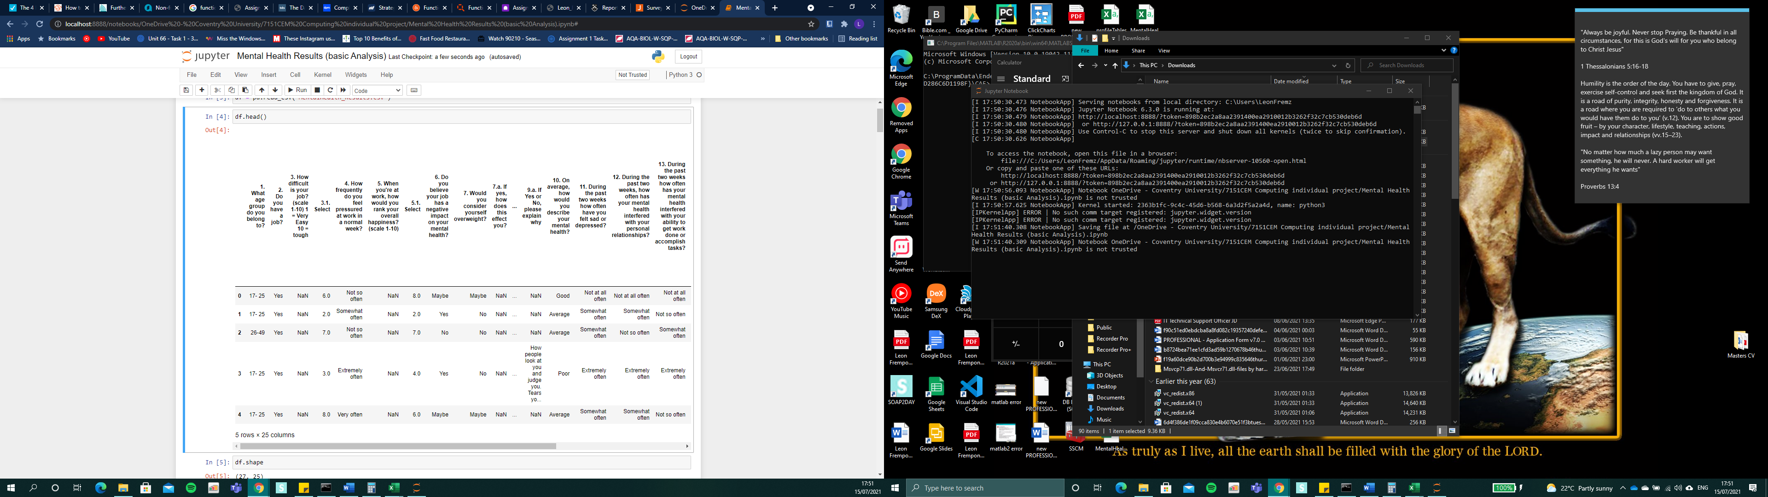

The columns are the survey questions

The datapoints are the results gathered by the participants

I

# 

questions which is presented in the dataset in the column’s sections

Detailed datapoints which is presented in the dataset

# Before I began the basic analysis, I tested out how each question was answers by the number of participants for each question. For example, question number 6 “Do you believe your job has a negative impact on your mental health?”, I added a python method ‘value.counts()’, which returns a series containing counts of unique rows in the dataframe. This question contains a multiple-choice single answer which is “Yes, No Maybe, I don’t know”. So, this method was able to count the number of participants who picked each of the multiple-choice answers. See below

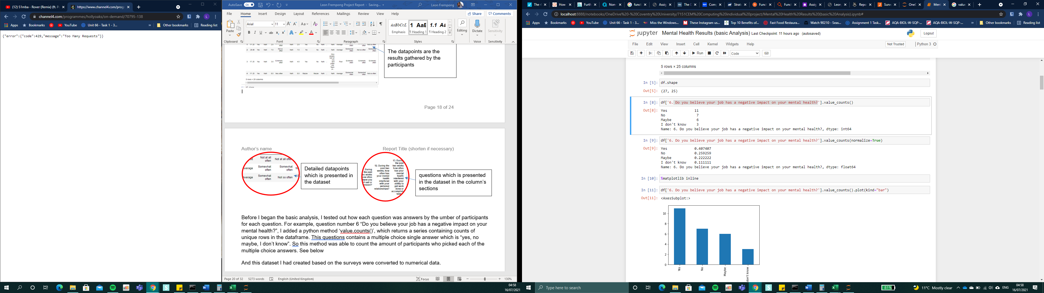

Each question used in the survey, we used as visual data, so that I could be able to visualise the answers in graph form.

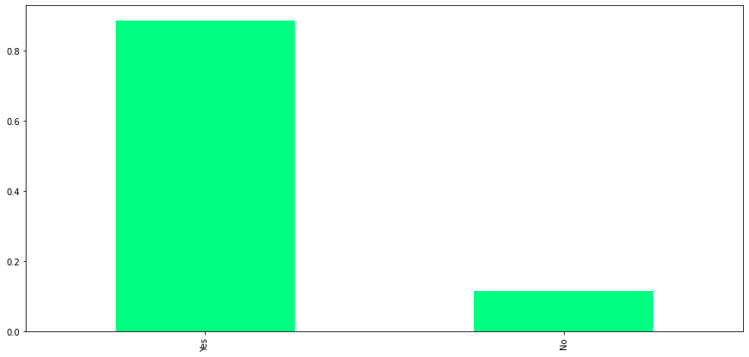

The graph above is based on the number of participants who has got a job and those who don’t. over 80% of my participants claimed to have a job compared to those who don’t. With this question I may be able to figure out how their mental health has been whilst working at their job, which can be based on how satisfied they are with their job or other reason which may have affected their work performance both physically and mentally. This is usually one of the factors that causes bad mental health.

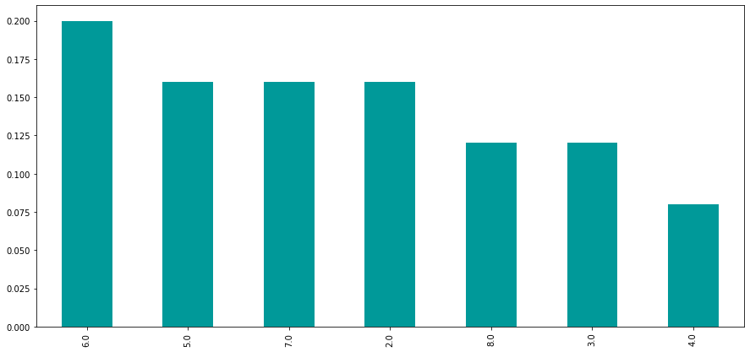

This graph are the results based on how difficult their jobs may have been. Based on questions, it required answers in rank(scale 1-10) 1 = Very Easy 10 = tough). It tells me that “number 6” is picked the most which over just above number 5. Number 6 is not portrayed as the toughest experience for the participants. This could mean that their job is not hard for them to handle. Surprisingly number 10 was not selected at all, which can imply that participants are in between satisfied and unsatisfied with their job experience. I could automatically assume that their mental health stage may not be affected as much. The least number selected is number 4, which was selected by only a couple or a few participants out of 27 of them.

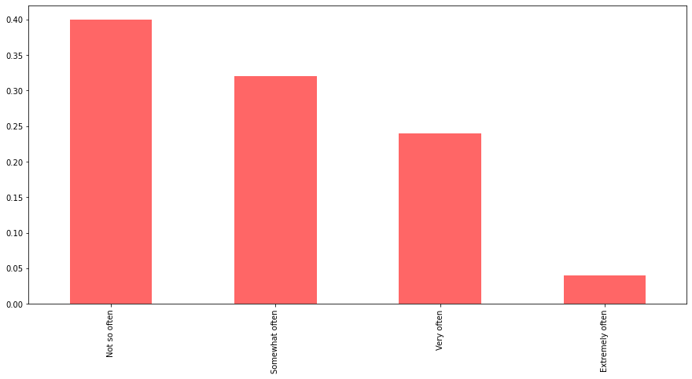

This graph above is based on how the participants may have felt at work in a normal week. 40% of participants claimed that they do not often feel any sort of pressure in a normal week at their workplace. 30% claimed that they somehow often feel the pressure, whilst 24% do claim they very often feel the pressure and 4% do feel the pressure very often. Those who selected “not so often”, may of not have any sense of experiencing the hardship in their workplace. They could possibly enjoy the experience. It tells me that it did not affect their mental health in any type of way at their workplace, so they do not feel the pressure at all. In contrast, those who claimed they feel that they get pressured “extremely often” and “very often” may feel the opposite, as pressure can naturally lead to a mental health issue, causing physical emotional and behavioural problems, due to constant bad experience. This result leads to the next graph result below.

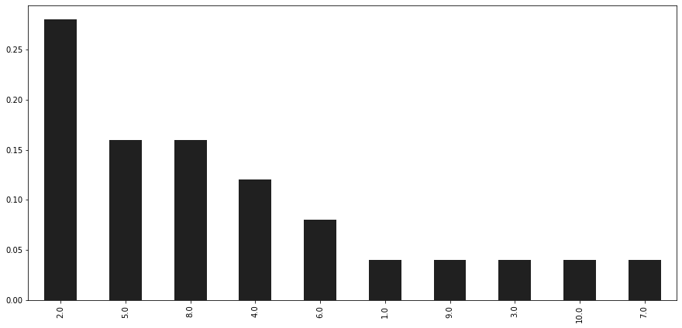

This graph above, is about how the participants would rank their overall happiness (scale 1-10) 1 = sorrowful - 10 = ecstatic. Over 25% participants selected number 2, which tells me that their well-being level is low. This could mean that the participants may have felt stressed at the workplace due to increase workload for example, which can cause mental health issue within the workplace. Employees normally would like to do the best job they can, and they can feel a responsibility to try and complete the task for a good impression. However, this may lead to stress if they get workload overtime. Perhaps the participants have a weakness in their personal skills such as time management and balancing their time between delivering their best work and wellbeing. Employers can also be the cause the of the problem. This may have impact on their health, private life. Due to the workload, this could affect their schedule such as going to the gym for example, it could change their diet, which can lead to unhealthy eating, weight gain, lack of exercise and increase stress. Relationships could be another factor at the workplace. In contrast, number “10” was selected as ecstatic. This is opposite well-being level from number “2”. The participant could be enjoying their job do not sense any type of stress or pressure, they’re able to balance their time, got time management skills and/or they do not receive workloads.

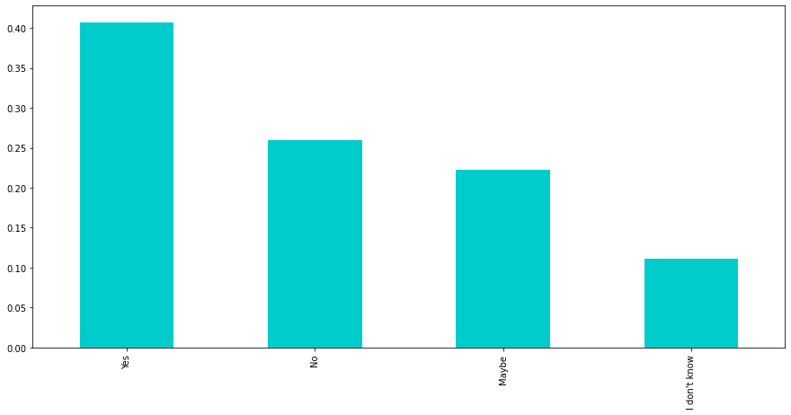

This graph is based on the opiniated question, “Do you believe your job has a negative impact on your mental health?” I wanted to get the participant’s opinion on whether mental health can be affected by their job. 40% picked “Yes”, 26% picked “No”, 22% picked maybe and 11% picked “I don’t know”. Most of the participants picked yes. This tells me that they may understand the causes of mental health and where it could come from. Mental health is very common, and it can take place easily. They may have the general knowledge, known someone who’s gone through it or have had their personal experience. Some of the participants are not sure about, perhaps they do not have any experience on it or a general knowledge about it.

The next section on the survey was about weight/physical appearance. Some of the questions are open questions, so that I could know their opinion and gain a broader knowledge on it.

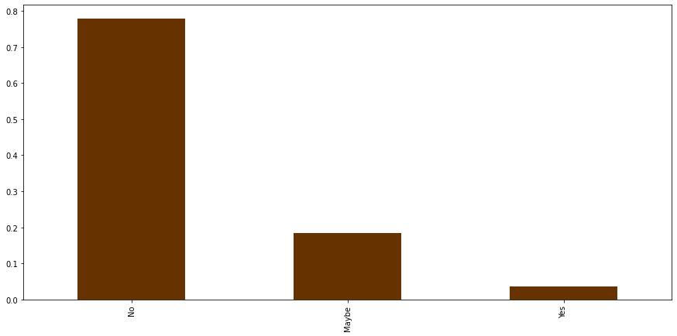

The graph above is the result of whether the participant think that they’re overweight. 77% do not believe that they’re overweight, 18% believe that they perhaps could be overweight and 3% believe that they’re overweight. In some cases, the participants know what it takes to know that they’re overweight, such as their physical appearance or numbers to demonstrate the definition of obesity in relation to their appearance. Another case may be that the participant may look overweight and do not believe / or know that they’re at the level of obesity. those who considered they are overweight expressed that they were affected by having self-esteem issues and anxiety. This is one of the forms that causes poor mental health, because of their physical appearance. See graph below.

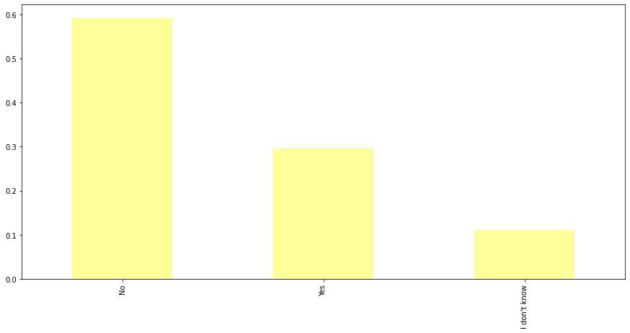

This graph above is the result of knowing whether they know anyone in their family or friends who’s struggled with obesity or not. 59% participants selected no, 29% selected no and 11% is not sure.

I included this question this to the survey for analyses because I wanted to know if they have anyone in the family or friend circle who has faced any effect/experience for looking like the way they do. This could be through hearing opinions of others, bullying, leading low self-esteem issues, low confidence. The following follow up question related to those who answered yes, are knowing how it affects them. All the answers were selected: 62.5% self-esteem issues, 25% depression, 25% anxiety, 25% stress, 37.5% physical health problems, 25% relationships with others, 25% social life and 25% remaining aren’t sure. This tells that they have been experiencing serious effect of looking overweight/obesity. The effects of obesity do not lead to anything positive. It often causes poor mental health status. Research shows that obesity leads to physiological and psychological consequences, this includes increased depression, anxiety and decrease self-esteem. More consequences are disordered eating, avoidance of physical activity and avoidance of medical care [3].

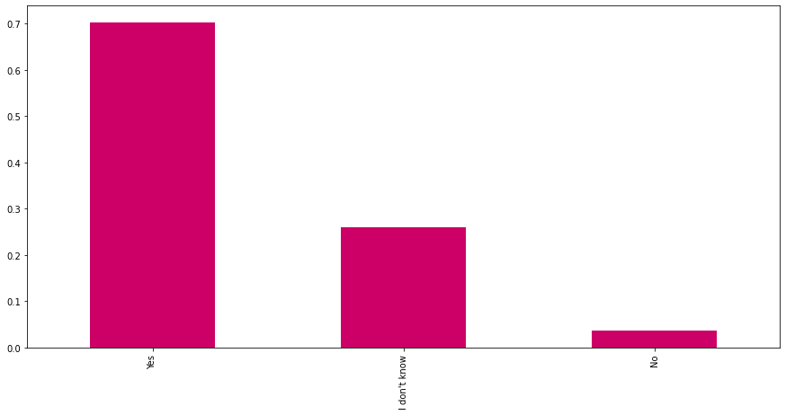

This graph is based on an open question. I wanted to know whether they believe that obesity has an impact on mental health. Those answered yes and no, would have to comment on their reason why they believe so. 70% answered yes, 3% answered no and 26% selected “I don’t know”. A participant believes that there is an obvious high correlation due to stress and anxiety. Other users have written similar answers such as resulting in low self-esteem, confidence, beauty standard, social pressure. Other participants have written length comments to explain why they believe it is the case. For example, a participant stated that ‘individuals puts their obesity in the forefront of their own minds, so whatever happens they automatically point to that sometimes; when it’s not even the case. Also, it can affect their confidence in activities that are not even physical. Another participant agrees and stated “Yes - Obesity has a major say in an individual social status affecting their overall quality of life. The issue normally stems from childhood obesity as a first instance in which children don't have an in depth understanding as to why they are feeling how they do which become borderline personality traits.” Another participant stated “Low-self-image and self- esteem that is a result of modern beauty standards. Also, obesity leads to lack of mobility and energy which makes someone feel tired often.” Another participant expressed that “Some people stress about being obese. Especially when they try to drop weight unsuccessfully, it might pressure them more making them more depressed.” Finally, “Being overweight can have a negative impact on one’s mental health as it can create a negative mindset and outlook on one’s life if one is overweight, especially if it impacts their day to day activities.” And “Some people might point out person is overweight, or the person just might think bad about themselves.”

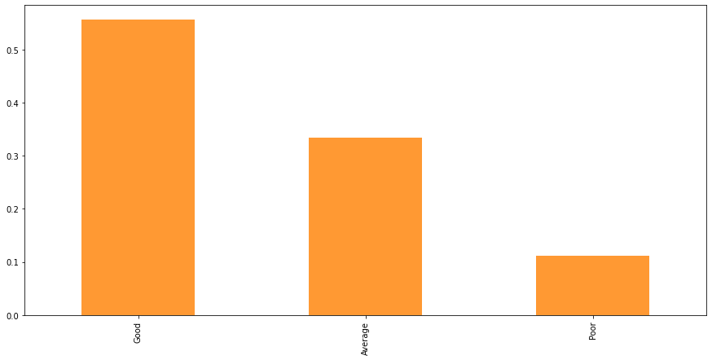

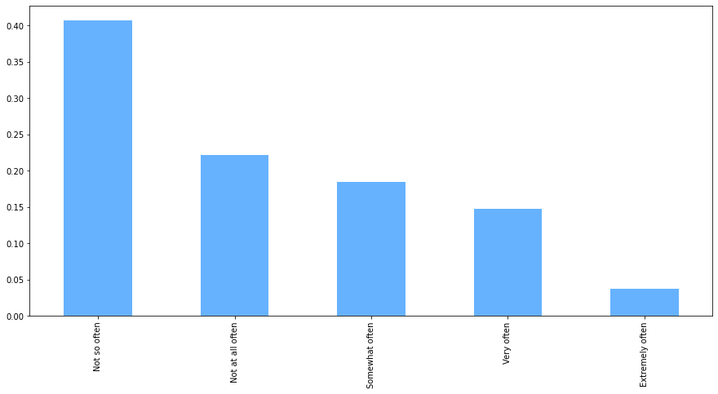

The graph above is the result based on knowing the participant’s mental health status. 53.6% of participants picked” Good”, 35.7% picked “Average” and 10.7% picked “poor”. This tells me that most of the participant’s mental health are in a good state compared to the least participants that picked poor. Also I had to ask them if they have felt sad or depressed in the past two weeks, most participants at 39.3% picked “not so often”, whilst 3.6% picked extremely often, 14.3% picked very often, 21.4% picked somewhat often and 21.4% selected Not so often. Based on these answers, these participants have shown to me that they are able to be aware and alert on their mental state. Signs that they have looked out for or may have faced could be: lacking energy and feeling tired, feeling exhausted all the time, finding it hard to concentrate, feeling tearful, not wanting to be around people, using alcohol or drugs to cope with feelings, finding it hard to cope with everyday things and tasks and experiencing burn out and other possible reasons.

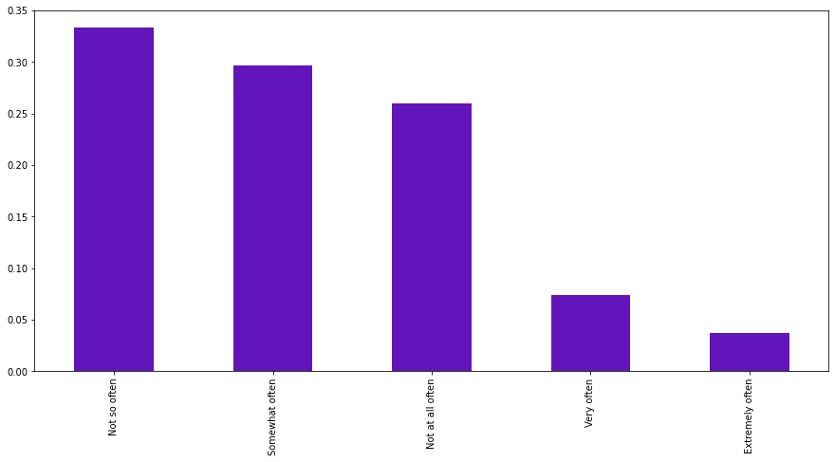

This graph above shows the result of knowing how often the participant’s mental health have interfered with their personal relationships. Same results at 32.1% selected “somewhat often” and “not so often”. 3.6% for extremely often, 7.1% for very often and 25% for not at all often

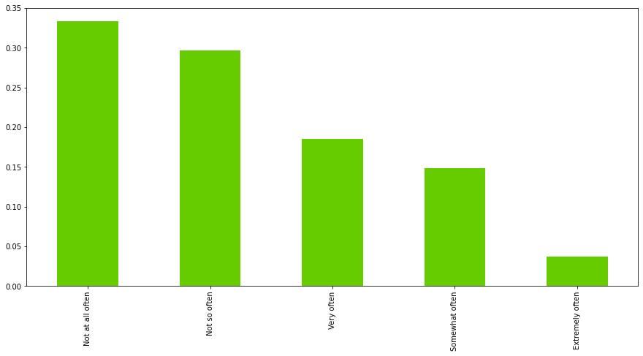

The graph above shows the result of how often the participants, mental health interfered with their ability to get work done or accomplished tasks. The most participants at 32.1% selected that they not so often and not at all often-experienced mental health which interfered with their ability to complete their tasks.17.9% selected very often, 14.3% somewhat often and 3.6% extremely. Those who often experience their mental health interference with their work task. This is often common. Poor metal health and stress can negatively affect employee: Job performance and productivity, communication, and relationship with their co-workers as well as their physical capability and daily functioning. Research shows that “depression interferes with a person’s ability to complete physical job tasks about 20% of the time and reduces cognitive performance about 35% of the time” [4]. Other participants who did not experience any of it in the last two week, may not have experienced it a certain level to the point where it affected their work performance or it could be that they have not experienced mental health issues at all.

The next part of the survey results is based on physical activities

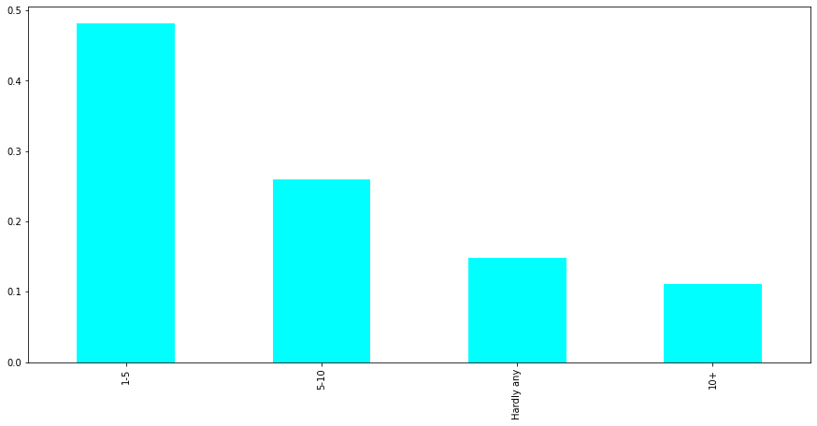

This graph result above explain the result of the number of hours per week of physical activities the participants took part in. On average most participants selected 1-5 hours at 50%, 25% of 5-10, 10.7% of 10+ hours and 14.3% at hardly any. There could be some reasons as to why 50% picked 1-5hours per week, compared to those that picked 10+ hours per week, due to their busy lifestyle, or some have just may have started doing physical activities and started doing it gradually. Those who picked 10+ hours per week, have put on loads of their time to do physical activities, due to the love of it as their hobby, or something that they feel determined to do.

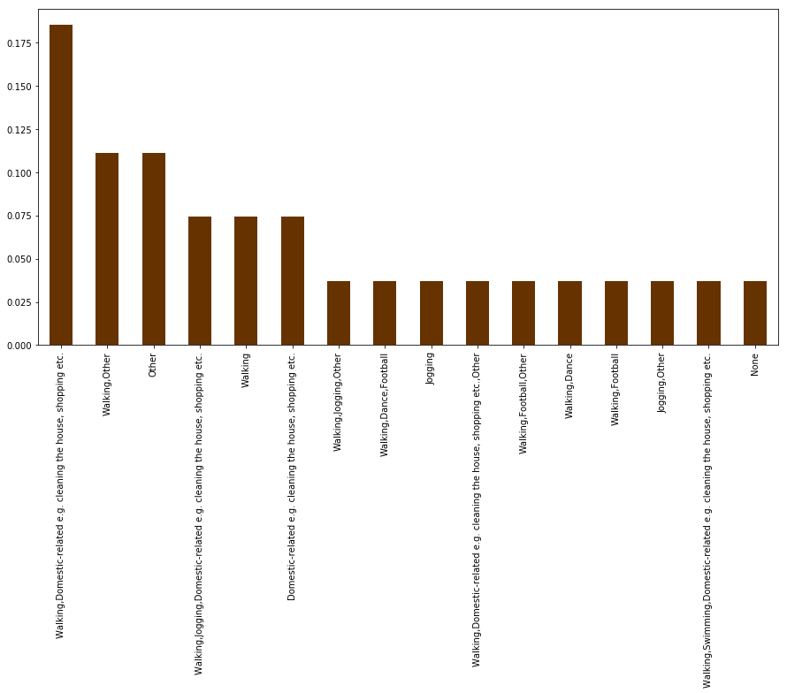

This survey results displays the type of physical activities that they currently take part. As you can see you, most participants selected “Walking, domestic-related”, as this seems to be most basic and simplest activities that we all do daily, compared to other activities such as, dancing, sports, weight training, martial arts and yoga.

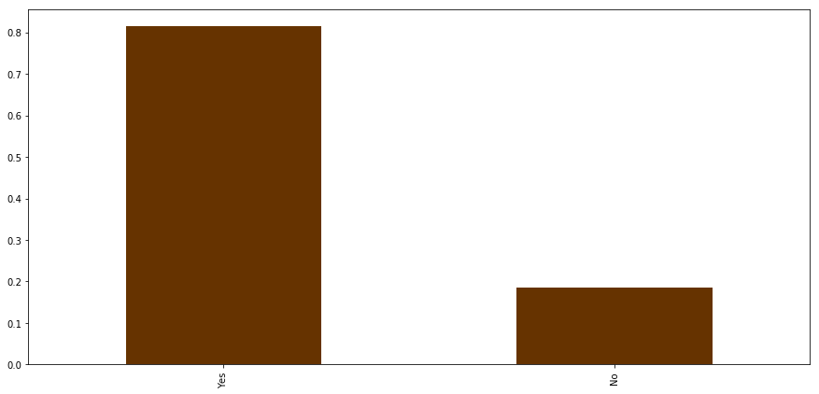

This last graph results are done based on a statement that the participant can whether agree and disagree to know if it applies to them. The statement was “I would like to take part in more sport and physical activity and believe that this would improve my general state of mental health”. According to the result, 80% picked yes and 20% picked no. The reason may have been that those who picked yes would love to do it but may not have time to do so or they may not have felt motivated to do so. Those who picked no way have either already been doing exercise or others may not be bothered at all.

# After gathering these results and created the graph for it, I did also notice that I needed to perform EDA (Exploratory data analyses) analysis. EDA is used for performing an investigations on my data so that it gives me the ability to perform such patterns for example, spotting anomalies, to test hypothesis and to check assumptions with the help of statistics and produce graphical representations. All in all, I can be able to understand my data first and gather insights to it. I performed two parts of EDA: 1 for the older datasets produced and 2 for the newest dataset.

To be able to show my understanding I can be able to show evidence on how I was able to do some. However, due to some of my data loss issue, I would be able to show some of the evidence based of data cleaning part of this investigation. so I am only able to provide evidence from the history “history --g”

I performed major data cleaning, so that I can be well presented in my dataset (Microsoft excel) and graphical visualisations. The dataset was firstly presented fresh from the survey results that gathered, which included the non-numerical data points in the rows and questions in the column. I began to start the cleaning process by dropping irrelevant columns and renaming the column name. after performing this operation, here is the sample shown below after performing it (this screenshot of the dataset had been converted to PDF).

I was able to display these results by writing the following code

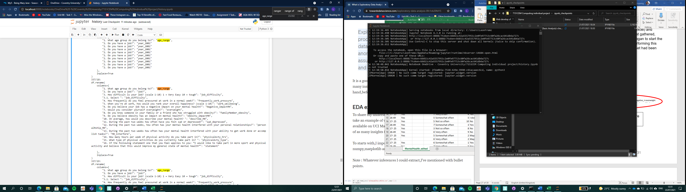

Here is how I was able to edit the dataset

I used “df.rename()” and “columns={}” function to perform this operation. Its succeeded and I was able to save it as “MentalHealth_edited.csv” it as a sample test to see how it looks. Whilst renaming the features, I tried my best to relate the names to the questions, so that it cannot be convenient to understand what each column were about.



**Before**: original feature names

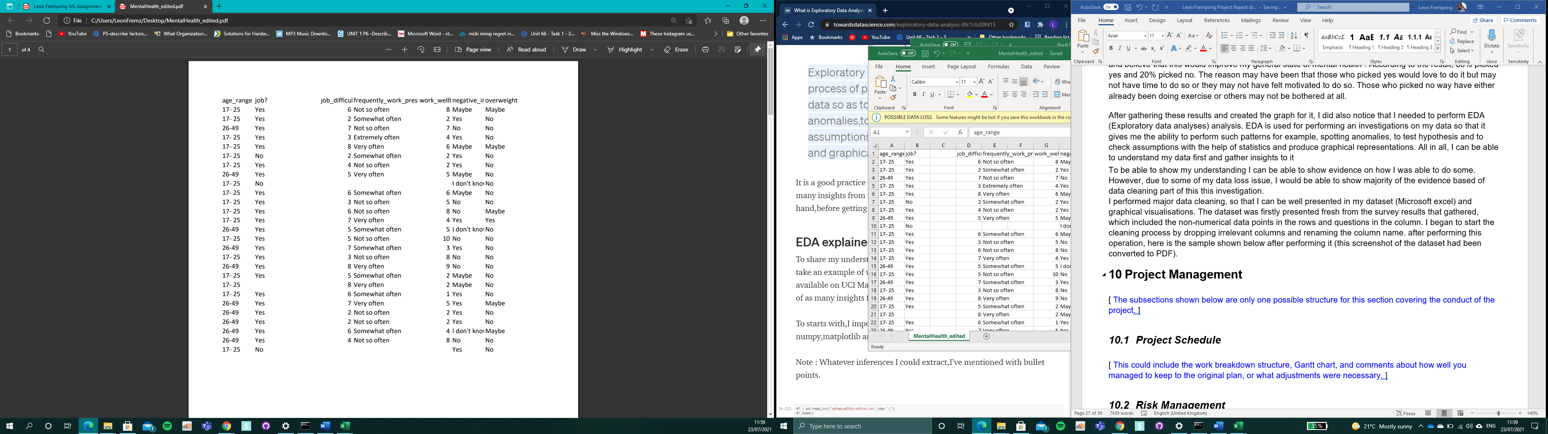

Here shows the newer dataset. Changes to name of features where done

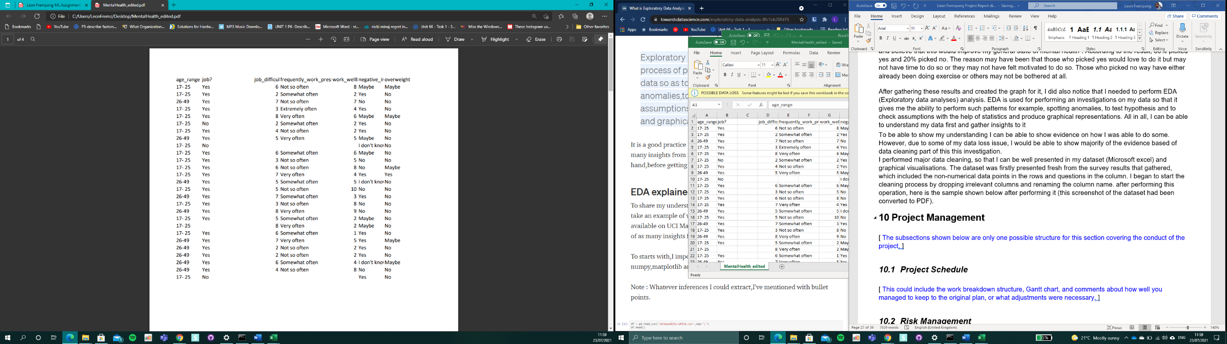

**After**: Renamed feature names

|  |  |
| --- | --- |
| **Old column names (primary survey questions)** | **New column names** |
| What age group do you belong to? | age_range |
| Do you have a job? | job |
| How difficult is your job? (scale 1-10) 1 = Very Easy 10 = tough | job_difficulty(scale 1-10) |
| How frequently do you feel pressured at work in a normal week? | frequently_work_pressure |
| When you're at work, how would you rank your overall happiness? (scale 1-10) | work_wellbeing(scale 1-10) |
| Do you believe your job has a negative impact on your mental health? | negative_impactMH |
| Would you consider yourself overweight? | overweight |
| Do you know someone in your family or a friend who has struggled with obesity? | fmlyMember_obesity |
| Do you believe obesity has an impact on mental health? | obesity_impactMH |
| On average, how would you describe your mental health? | describe_MH |
| During the past two weeks how often have you felt sad or depressed? | sad_depressed |
| During the past two weeks, how often has your mental health interfered with your personal relationships? | personalRship_MH |
| During the past two weeks how often has your mental health interfered with your ability to get work done or accomplish tasks? | MH_interfereWrk |
| How many hours per week of physical activity do you take part in? | physicalAvty_hrs |
| What type of physical activities do you currently take part in? | physicalAvty_type |
| If the following statement one that you feel applies to you: “I would like to take part in more sport and physical activity and believe that this would improve my general state of mental health” | Statement |

After performing this task, my next aim was to able to drop some unnecessary columns, such columns that required participants to writing down their personal comments/opinions or other answered that they wished to write down for example. While performing this operation, it would work, but after I would constantly get the unnecessary columns back. And I realised that my mistake was I either did not same the dataset right after edited it and/or mistakenly using the same variables to perform this operation. Due to this mistake, I ended up creating 3 newer datasets.

Here is the piece of code where I drop the columns

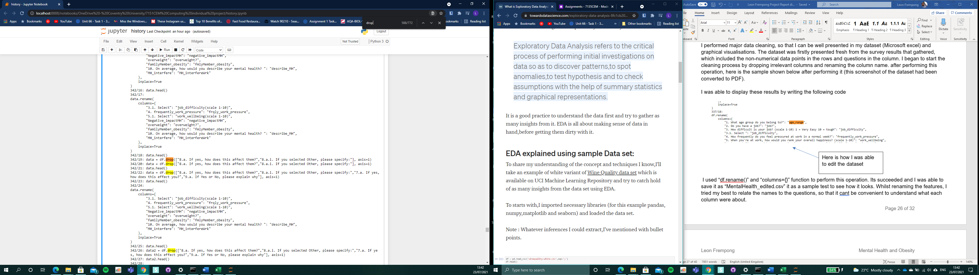

As you can see the columns that I dropped. It mainly based open questions that requires users to comment.

There were some cases where I drop some columns, even though some were able to drop, would always notice that column “15.a. If you selected Other, please specify:” would not disappear. See below

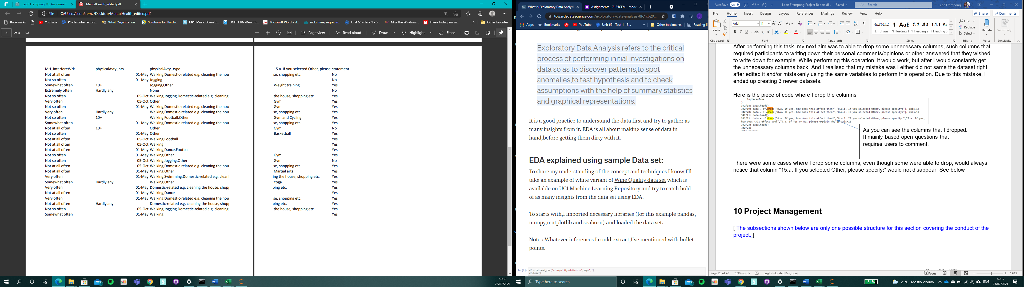

As you can see this is the column I tried to drop, even after constantly trying to remove it many times.

Next part of this cleaning process, I was identifying the patterns of the data points. I did this by identifying any missing data, incorrect values, duplicated information. If I do notice incorrect data, the outcome of my data and algorithms used would be unreliable and useless to use, as it may not provide the 100% accuracy of information. In this process I performed two different types of cleaning: data cleaning and data transformation. As you have known (explained above) data cleaning is the process that removed data that does not below in my data. Examples for this is dropping columns I that felt was unnecessary to keep. Another type I performed on my dataset was data transformation. It is the process that converts data from one format or structure into another.

In my case, my dataset contains a small amount of missing data points. See below

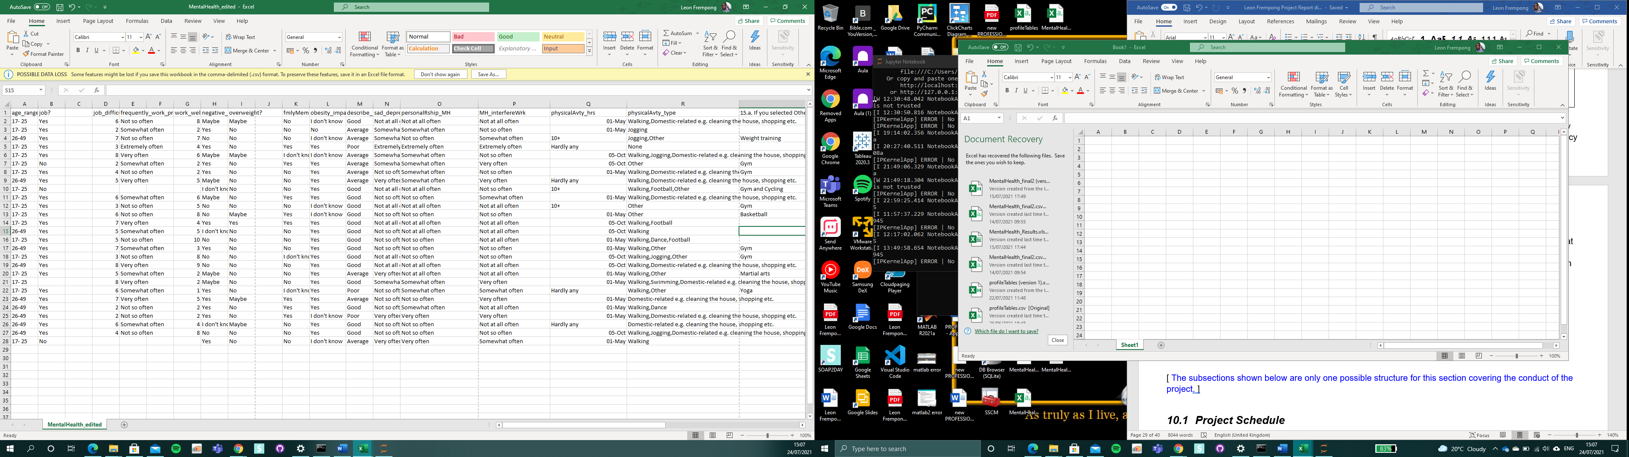

The screenshot shows some missing data points.

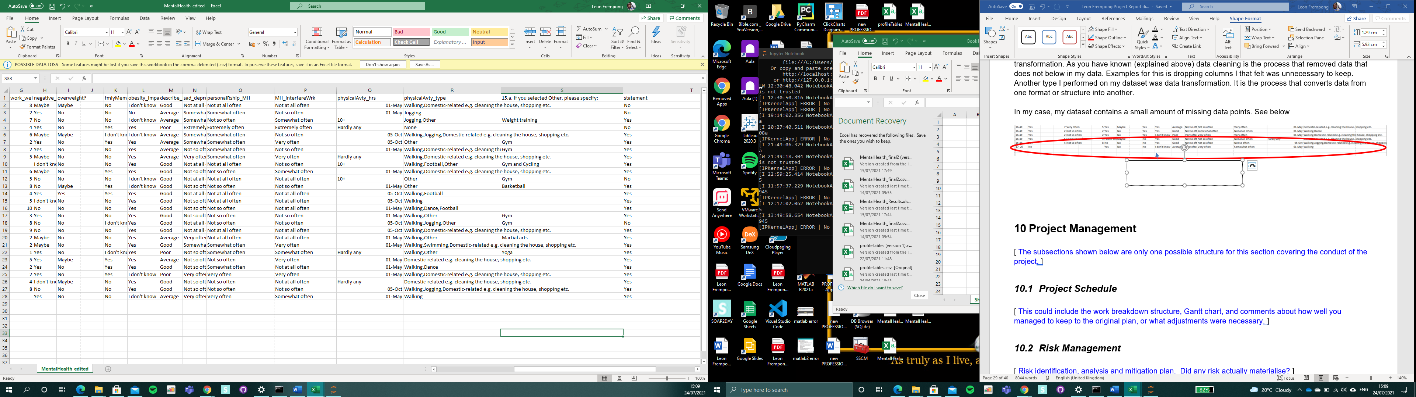

How I was able to overcome this was that I had to explore how to handle missing values using pandas.

I created the line “df.isnull()”. What the code does it shows a “False” if something is no null in the dataset (something that is not missing in the data points). However, a “True” may be shown if there is a null in the data points. (due to data loss from technical issue I am not able provide a capture for evidence). The methods are useful because, I could be able to identify where are the missing data points are. Moreover, I created a line “df.isnull().sum()”, which helps count the missing values from the dataset

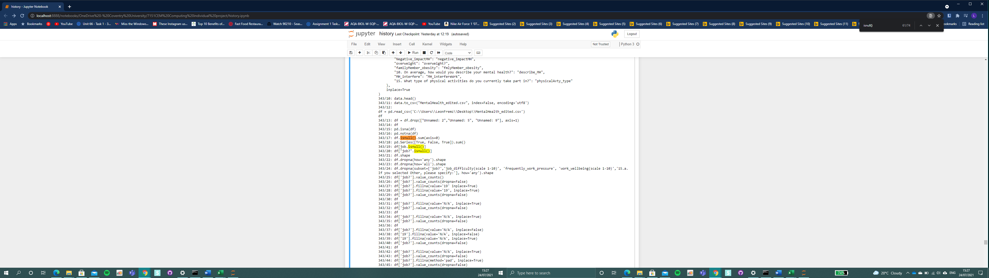

The data points that shows missing values, I figured that if I were to remove all the rows that contained missing data, I would have only 10 datapoints left out of 28 data points. So I decided to fill in the missing values based on other observations, even though I am aware that I can lead to data integrity of the data because I may be operating from assumptions and not actual real time observations. See below

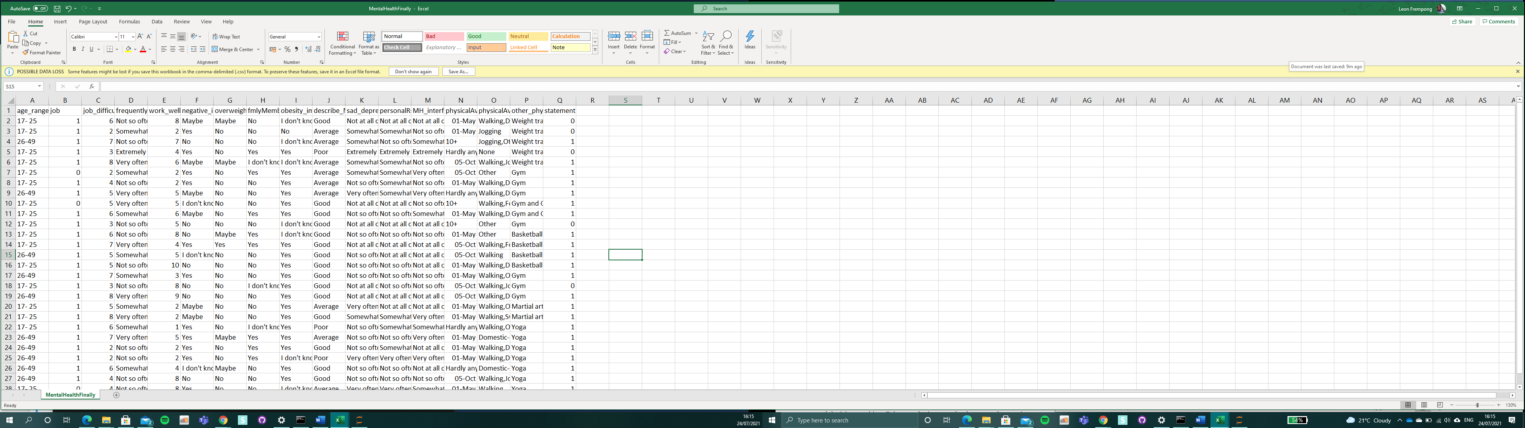

As you can see, by filling in the data points by using “fillna” and “bfill”, the dataset looks filled up with no missing values.

After I was able to perform it, I decided to start the Machine Learning process, however I realised that I was not able to perform certain tasks because the data points are not numerical. I ran to some issues as the system error message expressed that the data points are not numerical, so therefore it was not able to execute some tasks. So, part of this Data transformation processes, I must convert all the datapoint letters/phrases into numerical data. Below, I will be showing some examples of how I was able to perform data transformation.

As you can see the left screenshot, I created a function called “tran_age”( “tran” meaning “transformation”) for “age” column. I created an if statement that if the data displays age range datapoint is “17 -25”, the datapoint must be converted to the value “1”. And if the data displays age_range datapoint “26-49”, the datapoint must be converted to value “2”. “tran_age” now becomes a new column name (like a replacement column for “age_range”)

The second part of this operation is where I apply the function to the original column. See Below

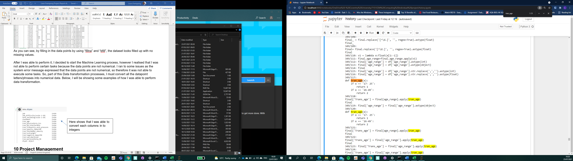

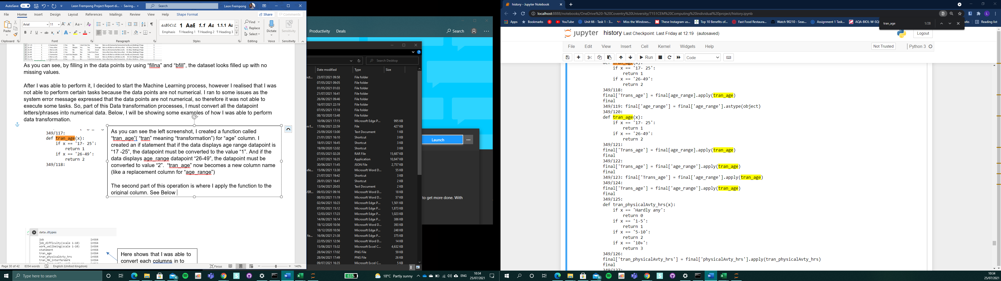

Another example as you can see below, I created a function called “tran_physicalAvty”( “tran” meaning “transformation”) for “physicalAvty_hrs” column. I created an if statement that if the data displays physicalAvty_hrs datapoint is displayed “Hardly Any, 1-5, 5-10, 10+”, the datapoint must be converted to the value either “0,1,2,3” depending on the answer provided.

The second part of this operation is where I apply the function to the original column.

*“final['tran_physicalAvty_hrs'] = final['physicalAvty_hrs'].apply(tran_physicalAvty_hrs)*

*final”*

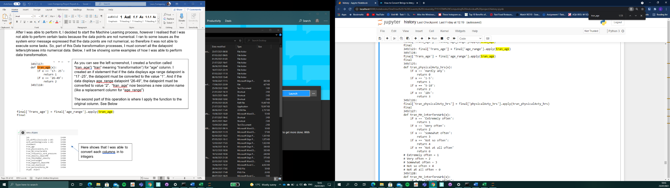

Below displays the table with shows the columns and its data points before and after data transformation

|  |  |  |  |
| --- | --- | --- | --- |
| **Old column** | **Old values** | **New Column** | **New Values** |
| job | 1.0 | tran_job | 1 |
| 0.0 | 0 |
| age_range | 17- 25 | tran_age | 1 |
| 26-49 | 2 |
| overweight | Yes | tran_overweight | 1 |
| No | 0 |
| Maybe | 2 |
| fmlyMember_obesity | Yes | tran_fmlyMember_obesity | 1 |
| No | 0 |
| I don’t know | 2 |
| obesity_impactMH | Yes | tran_obesity_impactMH | 1 |
| No | 0 |
| I don’t know | 2 |
| negative_impactMH | Yes | tran_negative_impactMH | 1 |
| No | 0 |
| Maybe | 2 |
| I don't know | 3 |
| sad_depressed | Extremely often | tran_sad_de**pres**sed | 1 |
| Very often | 2 |
| Somewhat often | 3 |
| Not so often | 4 |
| Not at all often | 0 |
| describe_MH | Good | tran_describe_MH | 1 |
| Average | 2 |
| Poor | 3 |
| frequently_work_pressure | Extremely often | tran_ frequently_work_pressure | 1 |
| Very often | 2 |
| Somewhat often | 3 |
| Not so often | 4 |
| Not at all often | 0 |
| personalRship_MH | Extremely often | tran_personalRship_MH | 1 |
| Very often | 2 |
| Somewhat often | 3 |
| Not so often | 4 |
| Not at all often | 0 |
| MH_interfereWrk | Extremely often | tran_MH_interfereWrk | 1 |
| Very often | 2 |
| Somewhat often | 3 |
| Not so often' | 4 |
| Not at all often | 0 |
| physicalAvty_hrs | Hardly any | tran_physicalAvty_hrs | 0 |
| 1-5 | 1 |
| 5-10 | 2 |
| 10+ | 3 |

Display datatype before and after result

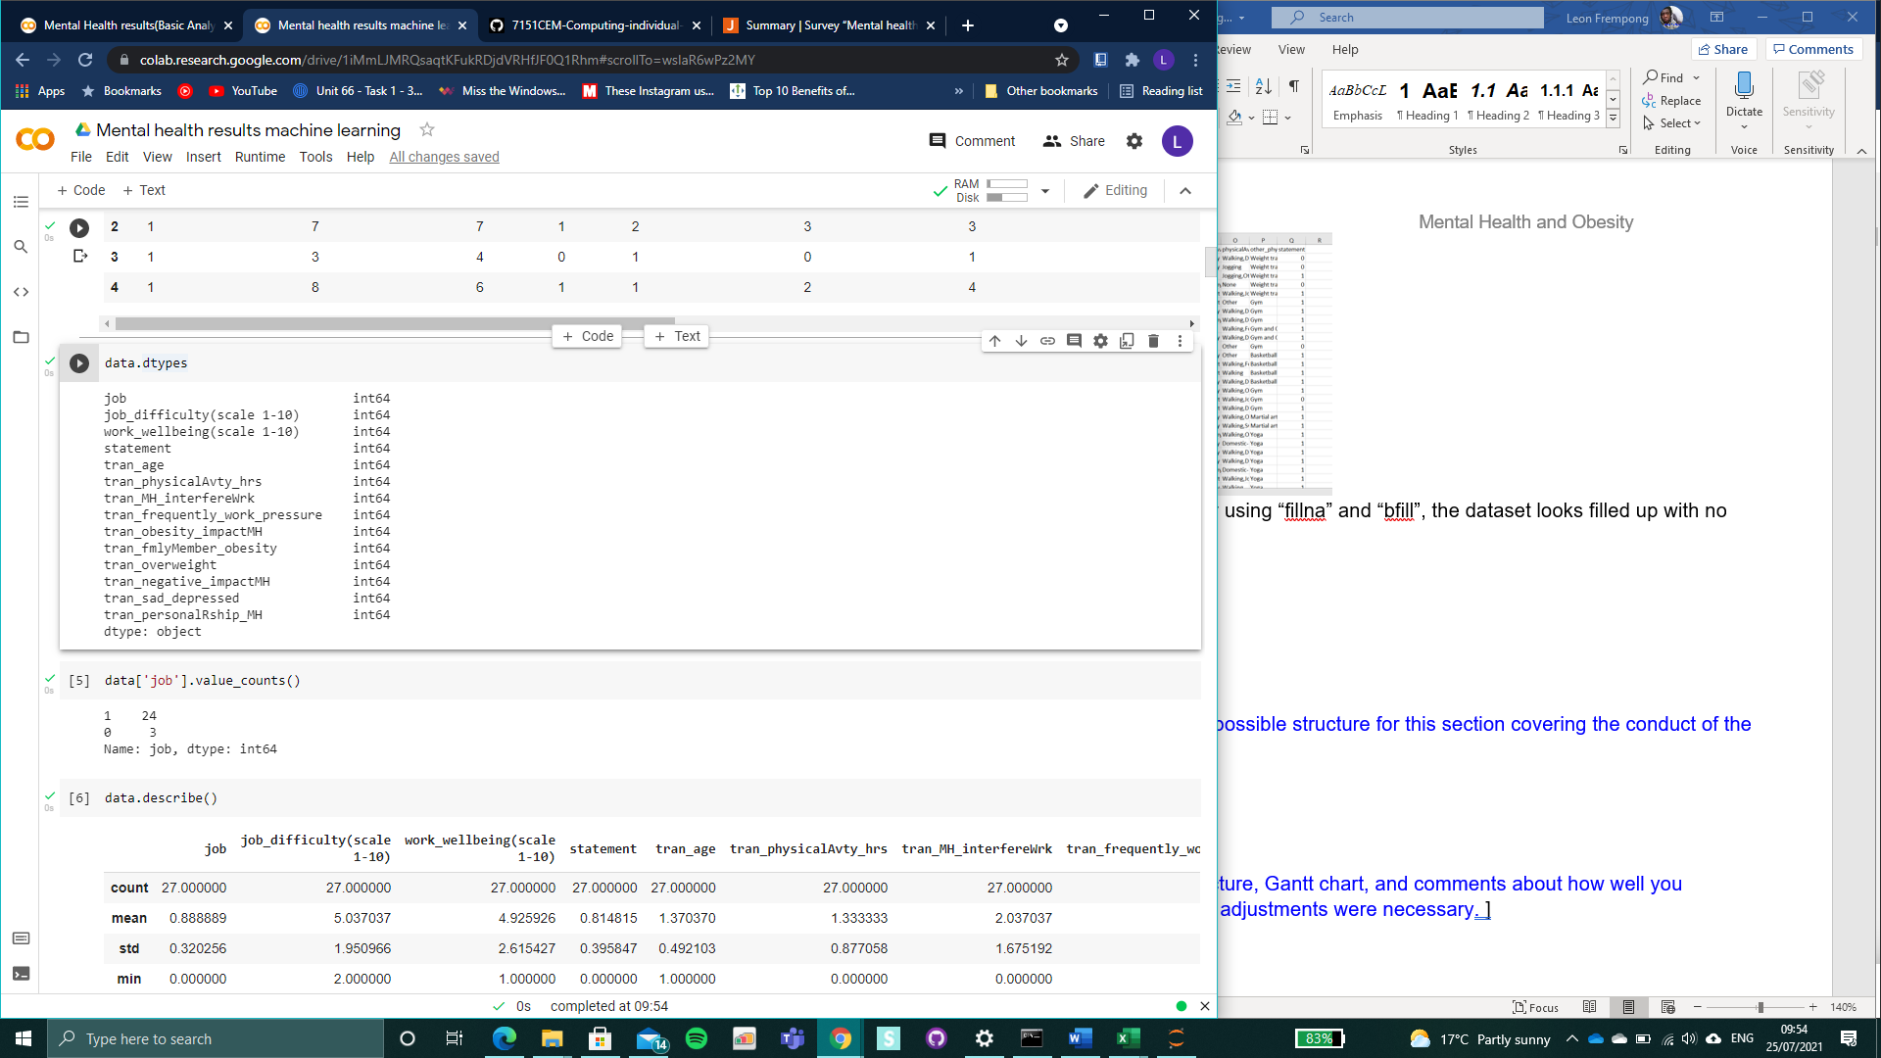

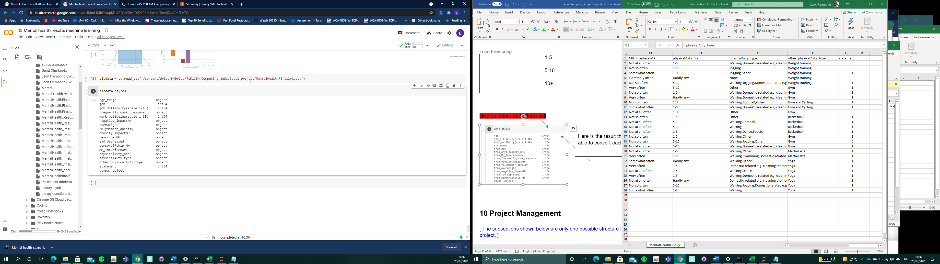

Here is the result that shows that I was able to convert each column into integers

Here are the datatypes before I converted all to integers

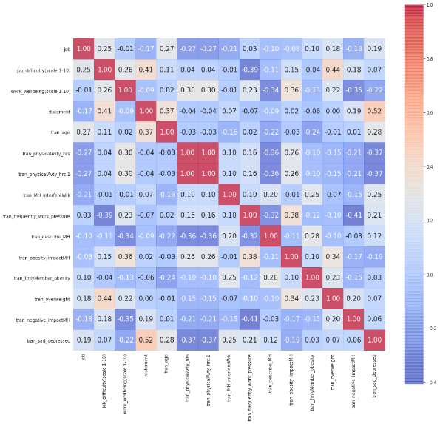

This heatmap is the plotted distribution of all the features from the dataset. As you can see, there are x-axis and y-axis. They define the feature. the figures in the table shows the correlation/relationship between each feature between each variable in high dimensional space. Each colour in the heatmap represents closeness of relationship between each feature. The “red” colour indicates the closest relations and the “dark blue” colour represents features with the most distant relationship.

Proofread

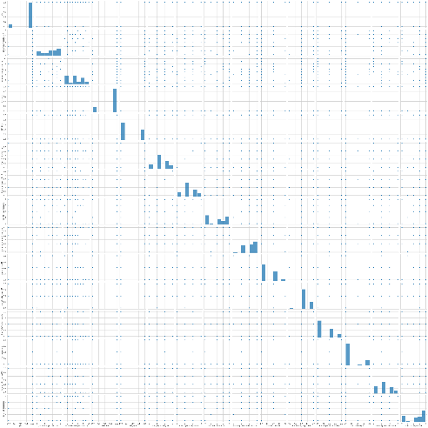

This screenshot displays the pair plot, to see pairwise relationships with every single variable. The axes in the grid represents each feature and their correlations to each other. It is generated by the pair plot function such that each vector in the data is shared across a single row in the Y-axis and across a single column in the x-axis. The set has 15 measurements and it contains different condition status(response) for 27 participants. The data is mapped by 11x11

Proofread

# PCA

I implemented PCA (stands for “principal component analysis”). It is a method used to reduce the number of variables in my data by extracting important information. It can reduce he dimension of my data with aim to retain as much information as possible.

Feature engineering – standardisation

Data standardisation is the data processing workflow that converts the structure is disparate datasets into a common data format. It deals with the transformation of my datasets.

I was able to implement standardisation.

1. Train-test

Training and testing enable my data to have better characteristics of my models but minimising the effects of data discrepancies. It is used for estimating the performance of machine learning algorithms where I could use to make predictions. After I can test my model by making predictions against the test set. In my case, I split my model in to two by 80% which is used to train, 20% using for testing and 70% for seed. Due to this operation I would be able to compare the performance for each machine learning algorithm for my predictive modelling problem.

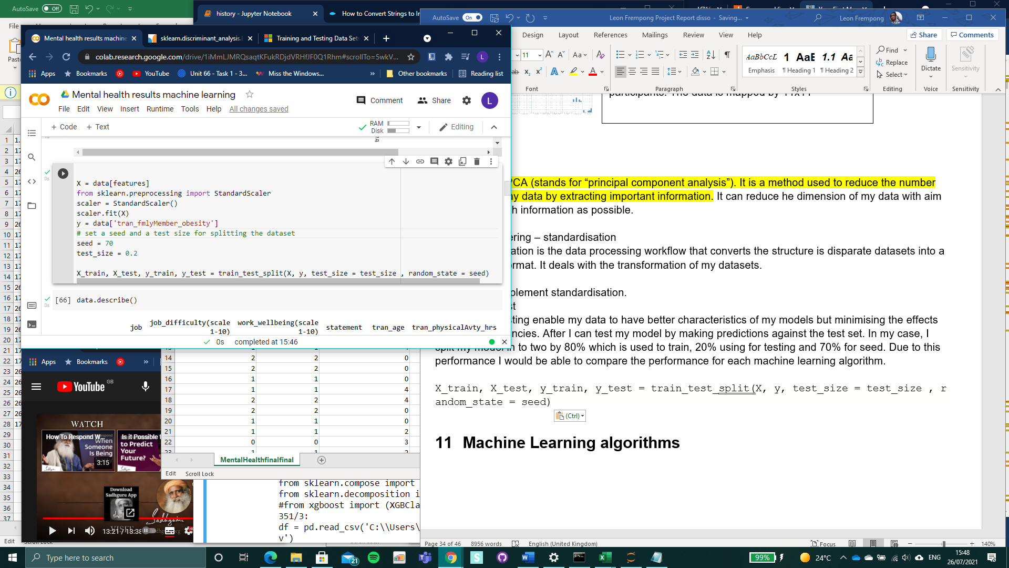

“x” for data features

“y” for data column “tran_fmlyMember_obesity”

My dataset is not a large dataset, because I was able to incorporate testing and training. I used the “scikit-learning” library to perform this operation.

1. Data Visualisation

The following screenshot below displays the 3 skew visualisations of the analysis gathered. The rest of the visualisations are displayed in the appendix section. To generate these results, I written code “**for feat in features**”, for loop which loops the features to create the graphs. Skewness is the calculation of how far a random variable’s likelihood deviates from the normal distribution.

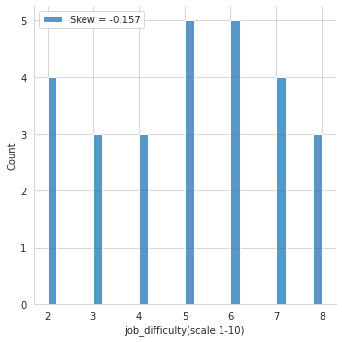

First example, in this case the visualisation shows a negative skewness. The value of the skewness (-0.157) shows that the distribution is negative. This tells me that “job_difficulty (scale 1-10)” variance. It is based on how difficulty can the job be for those who filled in my survey. The bars in labelled 5 in the y-axis shows there are 10 participants that selected 6 as their difficulty level for their job satisfaction.

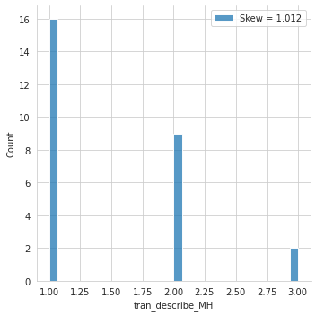

Second example in this case the visualisation shows a positive correlation. The value of this skewness (1.012) shows that the distribution is positive. This graph shows me a number of patients that mostly picked 1(Good) as the status of their mental health state compare to 2(Average) and 3(Poor) selected by the remaining participants.

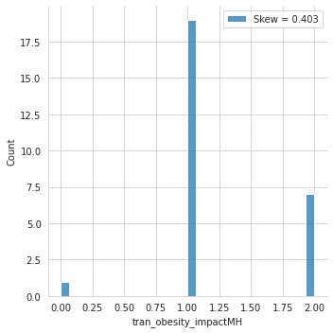

Third and final example in this case the visualisation shows a normal distribution. The value of this skewness (0.403). The graph shows the most counts for participants believing that there is an impact on mental health from obesity.

1. PCA (Principal Component Analysis)

This part of my project I created feature importance. I created feature importance because I provides insights to my dataset. The scores created highlights the features that is most relevant to the target. In my case, my dataset have got multiple classes. It does not predict the specific the specific target, but I believe it helps to provide reasons as to why participants go through bad mental health which could be causes from their physical appearance of their jobs. Moreover, it has the potential to improve my “predictive model”.

Here is my graph below

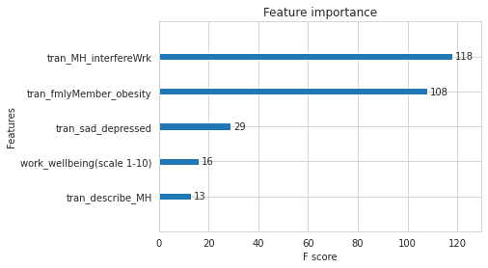

As you can see, each of the columns are all related to one thing, mental health factors. This feature importance is based on the test and train split method alongside “X = data[features]” and “y = data[tran_fmlMember_obesity]”. I chose to use “tran_fmlMember_obesity”, because according to my dataset, there were numerous responses of how that effected them with their mental health. Thankfully feature importance was able to pick up other features which were relevant to “tran_fmlMember_obesity” feature, by measuring each feature. Tran_MH_interferewrk has got the most feature importance. This is shows that it is most important compared to tran_describe_MH which has got the lowest.

1. Principal Components

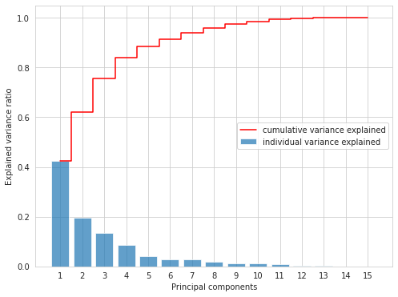

This graph above displays the principle components. It is defined as simplifying the complexity in high-dimensional data while retaining trends and patterns. The new variables that are built as linear combinations or mixtures of the original variables are the primary components. This variation is performed in such a manner that the new variables (main components) are uncorrelated and much of the information is squeezed or packed in to the first components within the original variables.

Based on my graph, there are 11-dimensional data in relation to my dataset which gives me 11 main component. PC seeks to put the first components the maximum possible information then remaining information in the next 10 components. This approach helps decrease the dimensionality without missing too much details by discarding the low-information components and treating the remaining components as my new variables

# Machine learning algorithms

This section I would be discussing about my findings, testing out algorithms and using the best suited algorithm.

My purpose of implementing machine learning is to discover patterns in my data and then make predictions based on complex patterns to answer my research question, analysing trends and help myself solve problems.

To start this process, I decided to test out all of the six algorithms; logistic regression, linear discriminant analysis, KNeighbours classifier, Decision Tree classifier, Gaussian NB and SVC (support vector classifier). I tested all these algorithms because I did not know which algorithms would be good for this problem or what configurations to use.

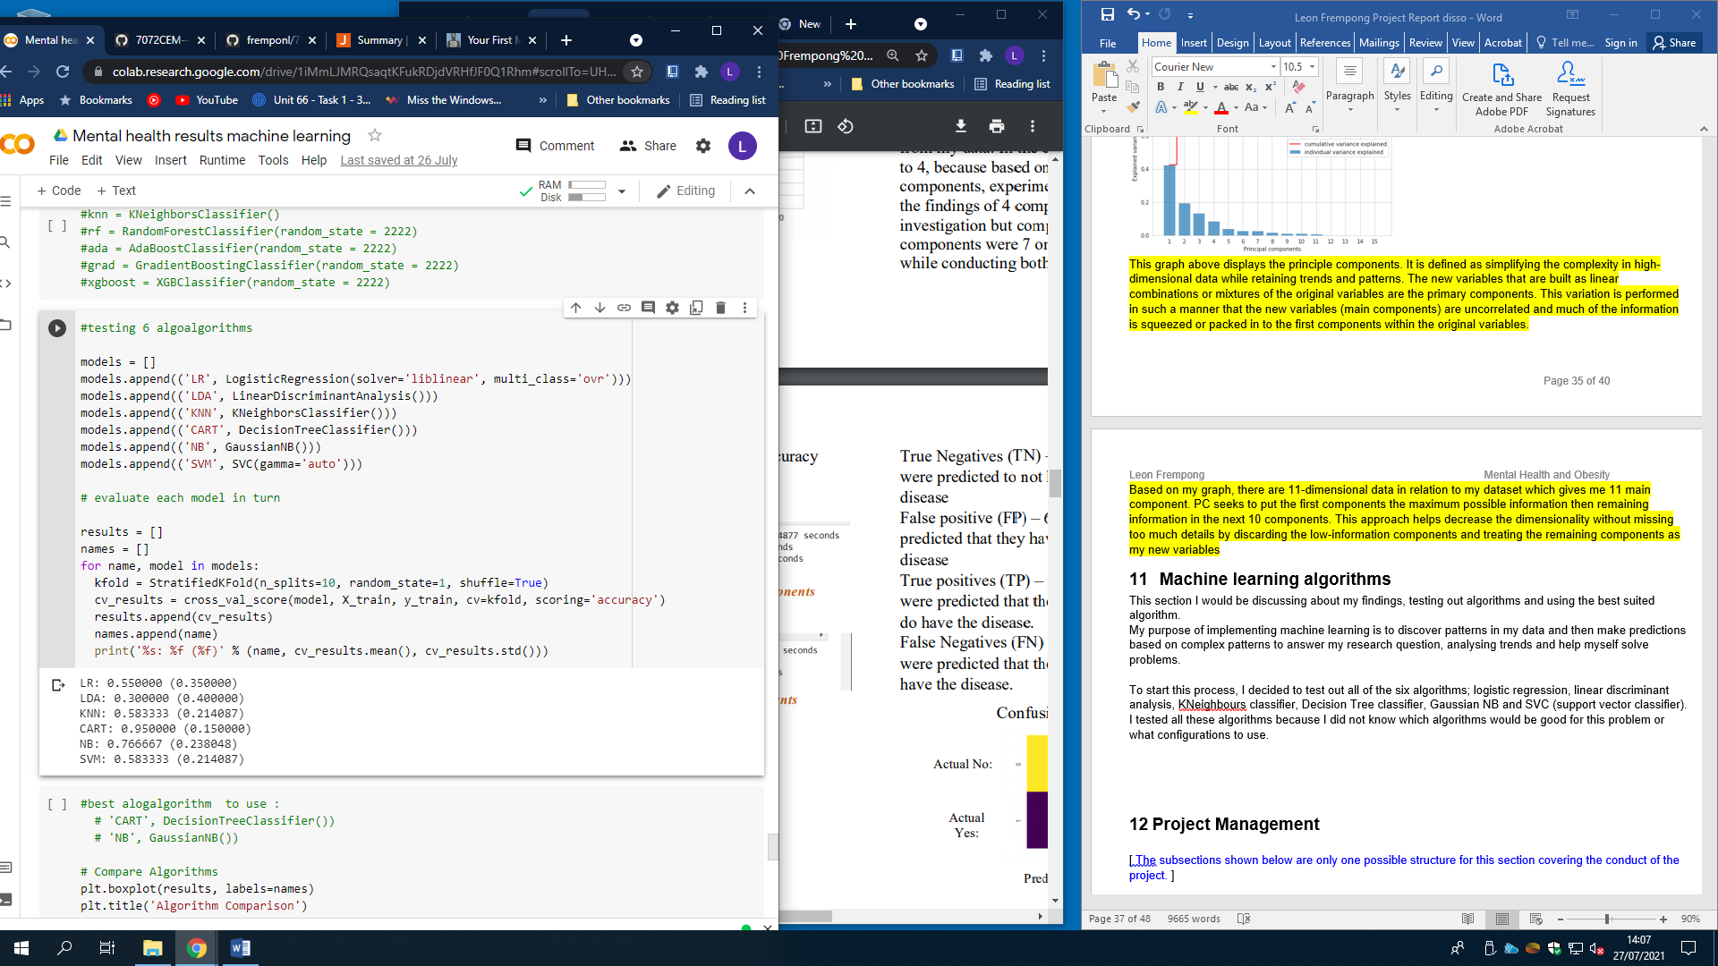

Based on my results above. It shows the accuracy estimation results from each of the algorithms. After doing this, the models needed to be compared to each other and then I select the most accurate estimations. In this case I picked two best algorithms, Decision Trees (CART) (95%) and Gaussian Naive Bayes (NB) (76%). Another way to compare the results of the algorithms, was that I created a box plot for comparison, see below.

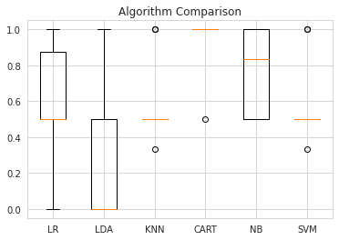

To move forward with the prediction, I had chosen decision trees and Gaussian Naïve Bayes, even though decision trees has the most accurate model. I wanted to get an idea of the accuracy of the model on my validation set. This way, I would be given a final validation check on the accuracy of the best model. I kept the validation set, in case I made a mistake during the training, for example overfitting on the training set.

Here is my prediction evaluation result for Decision Tree Classifier

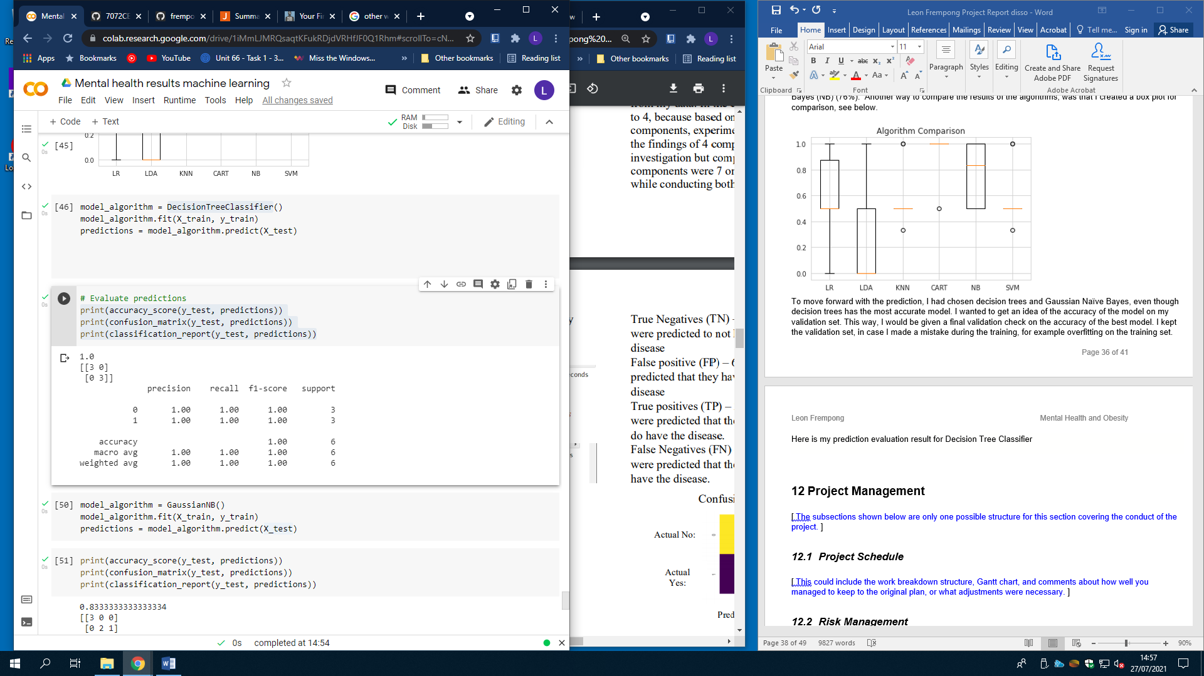

Here is my prediction evaluation result for GaussianNB

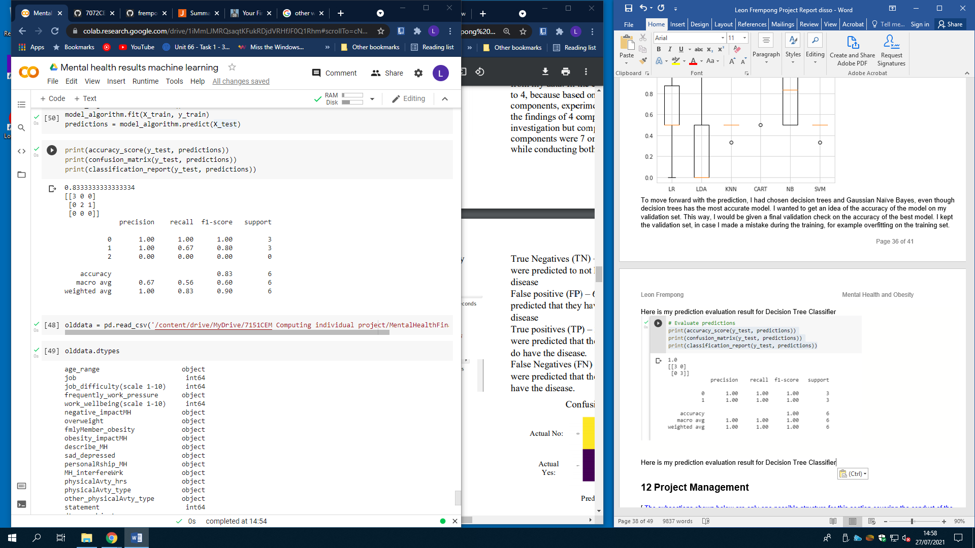

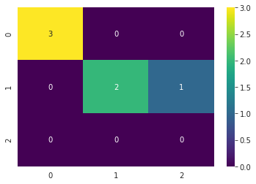

# Existing dataset for analysing patterns/trends

In this section I decided to find an existing dataset, so that I could use it to establish a baseline and trends. I want to be able to compare my raw information to existing information, in order to formulate a critical discussion.

The existing dataset I decided to incorporate in to this project are “mental health in tech survey”. I chose this existing project because it relates to my mental health project. This existing project is linked to employee’s attitudes towards mental health and frequency of mental health disorders in the tech workplace and it was taken in 2014.

This dataset contains 27 columns and 1259 data points.

# Project Management

[ The subsections shown below are only one possible structure for this section covering the conduct of the project. ]

## Project Schedule

[ This could include the work breakdown structure, Gantt chart, and comments about how well you managed to keep to the original plan, or what adjustments were necessary. ]

## Risk Management

[ Risk identification, analysis and mitigation plan. Did any risk actually materialise? ]

## Quality Management

[ Standards adopted, techniques used to review progress and evaluate outcomes etc. ]

## Social, Legal, Ethical and Professional Considerations

[ Consideration of professional, social, legal and ethical issues, e.g. Data protection, Privacy laws, ethical position, code of conduct, social implications etc. ]

# Critical Appraisal

[ A dispassionate and detailed discussion and analysis of the work and its outcomes, both positive and negative. The section will demonstrate the knowledge and expertise that you have gained from your project.]

# Conclusions

[ Optional introduction ]

## Achievements

[ Comment on what you have achieved in terms of product or other results, with reference to the original project objectives. ]

## Future Work

[ Outline possible enhancements or extensions to the product, or further work needed to address outstanding issues, etc. ]

# Student Reflections

[ A reflective and critical appraisal of your personal performance, problems encountered and how they were resolved, lessons learnt, what could have been done better or differently, etc. ]

Bibliography and References

[ Provide a complete list in APA referencing format of both the sources you have read but not used directly (bibliography) and those sources you have cited in your report (references). A single list will suffice. ]

#### [1] How common are mental health problems? (2021). Retrieved 1 July 2021, from <https://www.mind.org.uk/information-support/types-of-mental-health-problems/statistics-and-facts-about-mental-health/how-common-are-mental-health-problems/>

#### [2] Baker, C. (2021). Obesity Statistics. Retrieved 1 July 2021, from <https://commonslibrary.parliament.uk/research-briefings/sn03336/>

#### [3] World Obesity Day: Understanding the social consequences of obesity. (2017). Retrieved 20 July 2021, from <https://www.euro.who.int/en/health-topics/noncommunicable-diseases/mental-health/news/news/2017/10/world-obesity-day-understanding-the-social-consequences-of-obesity#:~:text=Stigma%20is%20a%20fundamental%20cause,and%20avoidance%20of%20medical%20care>.

#### [4]Mental Health in the Workplace . (2021). Retrieved 20 July 2021, from <https://www.cdc.gov/workplacehealthpromotion/tools-resources/workplace-health/mental-health/index.html>

Appendix A – Project Specification

[ Include here the documents submitted for the Project Specification ]

Appendix B – Interim Progress Report and Meeting Records

[ Include here the interim progress report and supporting documentation submitted ]

Appendix C – Requirements Specification Document

[ You may include here the agreed list of requirements signed off by the client. If the requirements document is too large then put it separately on the CD rather than as an appendix to the report. ]

Appendix D – User Manual

[ Include this if it’s fairly short and you feel it helps the reader understand the product without having to look for this information on the CD. ]

Appendix E – Project Presentation

[ Include here the slides or documents presented for the Project Presentation ]

Appendix F – Certificate of Ethics Approval

[ Include here a small screenshot of the “Certificate of Ethics Approval” on your project produced in the Ethics system for evidence ]

Appendix X – As required